Physics Final Project

Andrew Amaro-Olivo
Ruben Romero
Anish Jaishi Mishra

Rube Golberg Machine to ring a bell

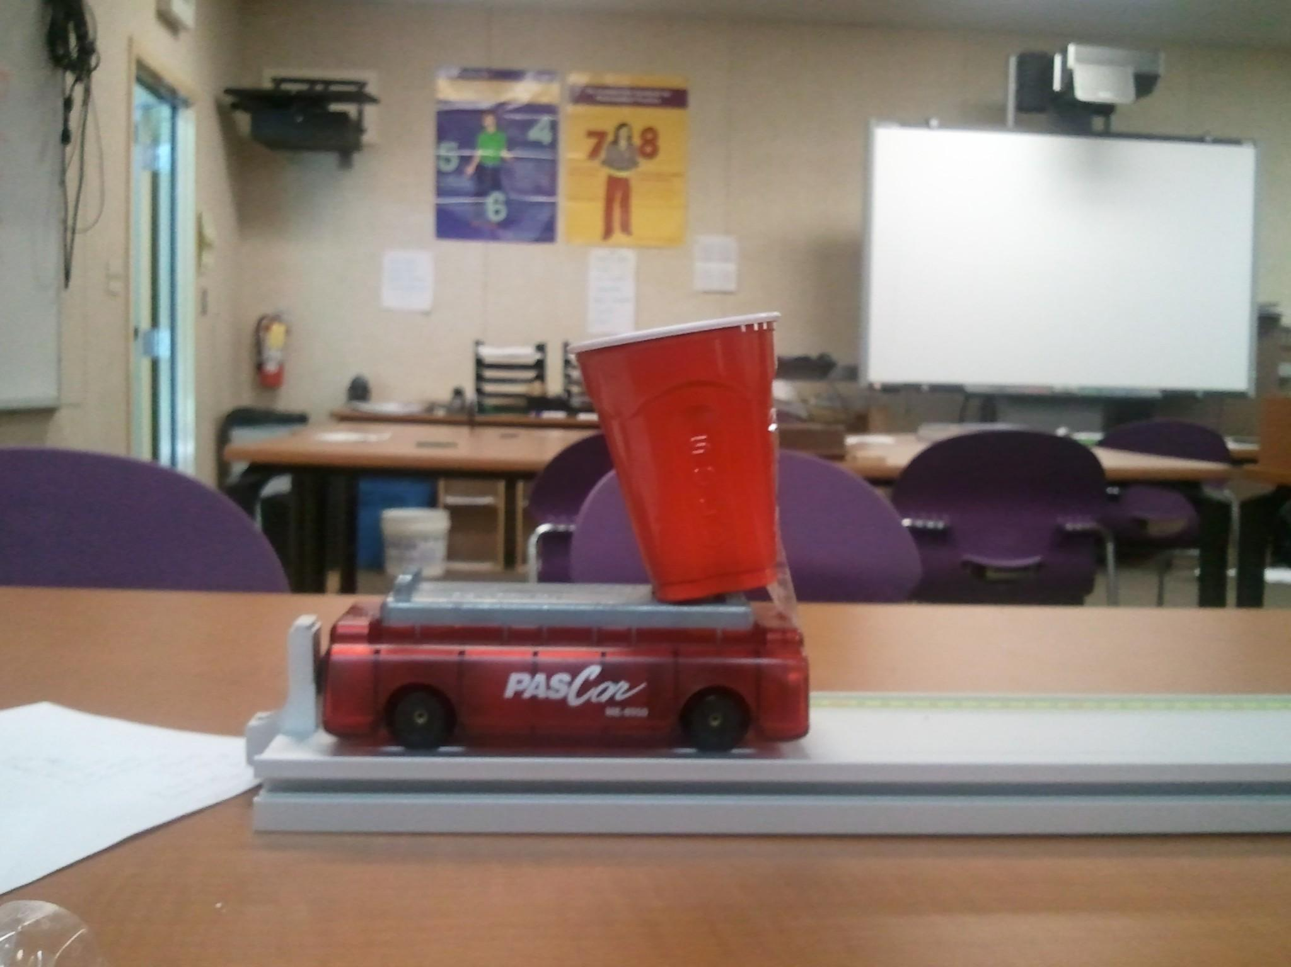
The car launches forward due to Newton’s third law. The potential energy stored in the spring of the car changes to kinetic energy after it hits the metal piece at the end of the platform. The car along with the cup and the metal ball in it get in motion.

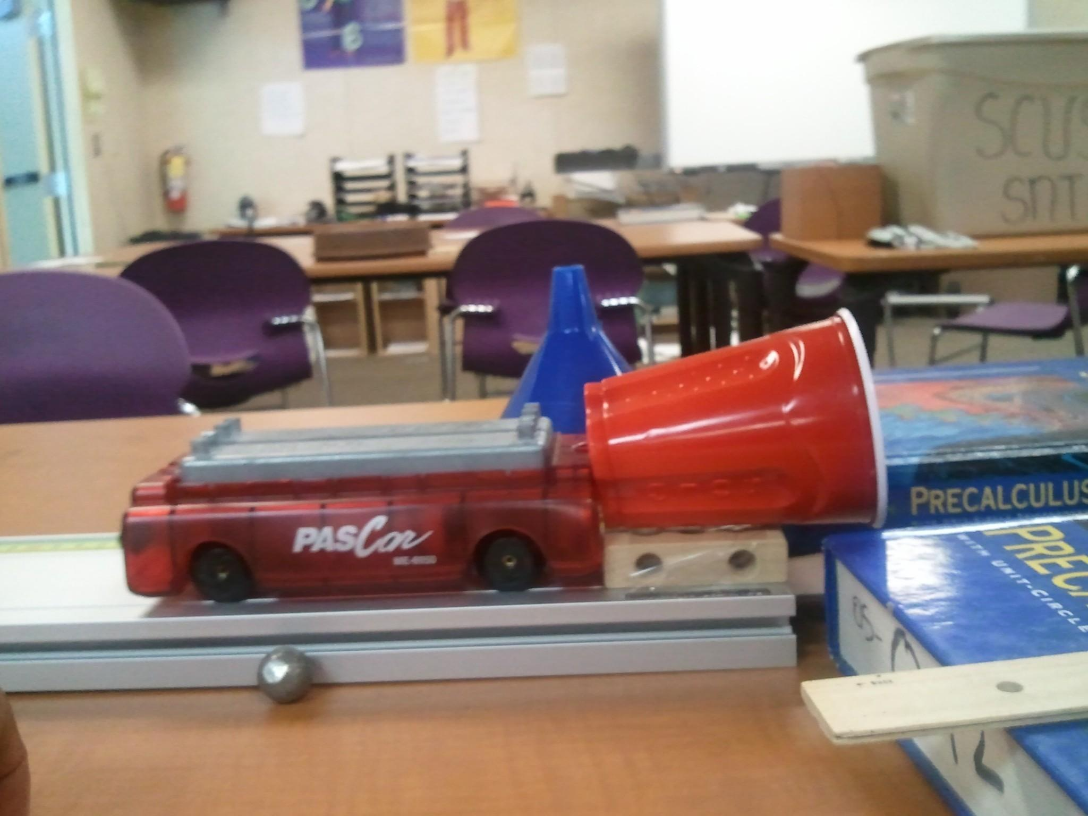

The car then collides to the wooden block, which is taped to the metal platform. The collision creates the Newton’s third law, in which the car moves the metal platform. But the inertia of the car is less than the platform, which stops the car. The cup and the ball in it are still in motion. The cup knocks forward because of the inertia of motion. The energy transfers from the cup to the metal ball in it. The metal ball rolls forward with kinetic energy and drops on the plastic cup at the end of the table. 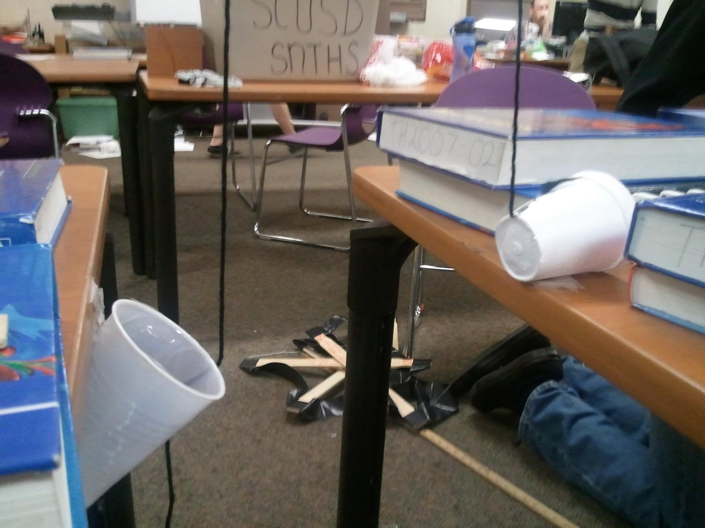
After the metal ball rolls in the cup, it goes down as the force on the cup increases due to the increase in mass. The pulley that holds the strings attached to the cups, keeps the force the same, but changes the direction. This makes the foam cup on the other table go up. The golf ball inside the foam cup rolls forward as it gains kinetic energy from the cup.

Andrew Amaro-Olivio

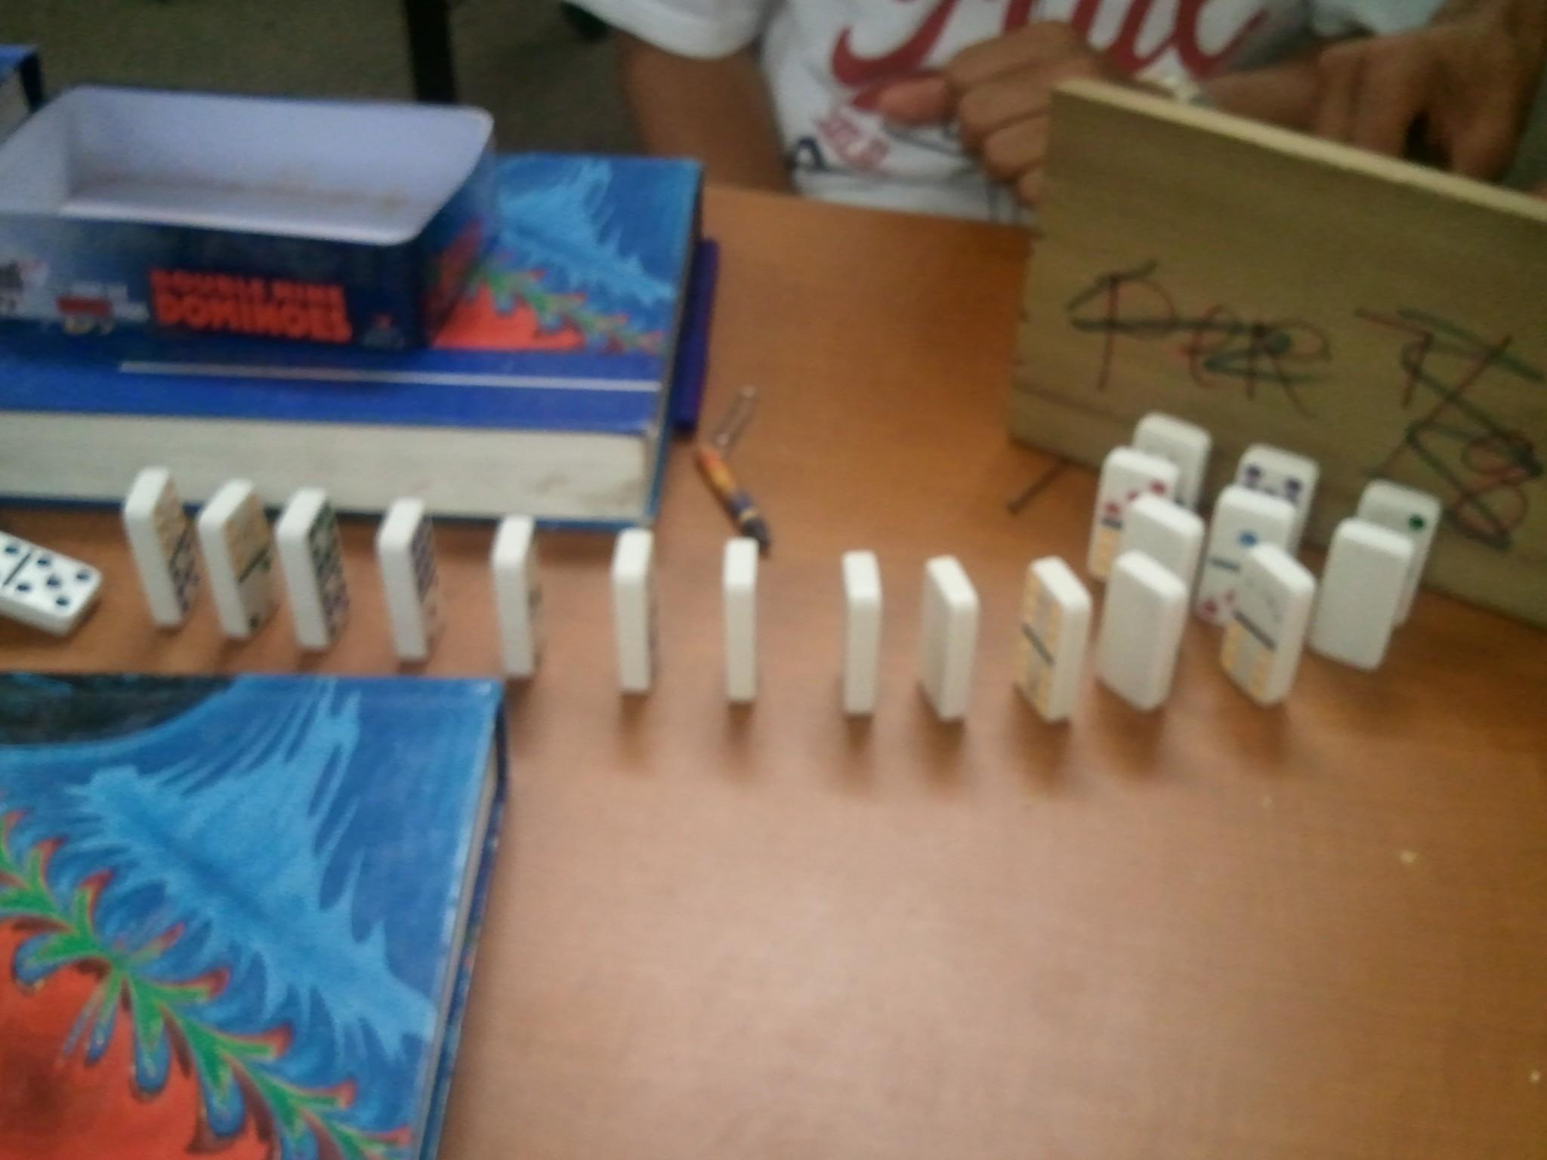

The golf ball then knocks down a domino (dominoes are thin and tall and have dimensions that are stable enough to stand upright yet unstable enough to fall over with a slight force. Therefore, even a slight force from the golf ball knocks down the domino.) A certain amount of work is done when the golf ball knocks down the domino. After the first domino receives a force from the golf ball, it falls forward and then gravity changes the potential energy of that domino into kinetic energy. The energy gained by the first domino is enough to knock down the second domino and the energy gets transferred from one domino to the other and knocking them over. At the end of the line, there are three dominos (that increase the work three times) to knock over a bigger plank. There is a pin under the plank to make it unstable and make it easier to knock it over.

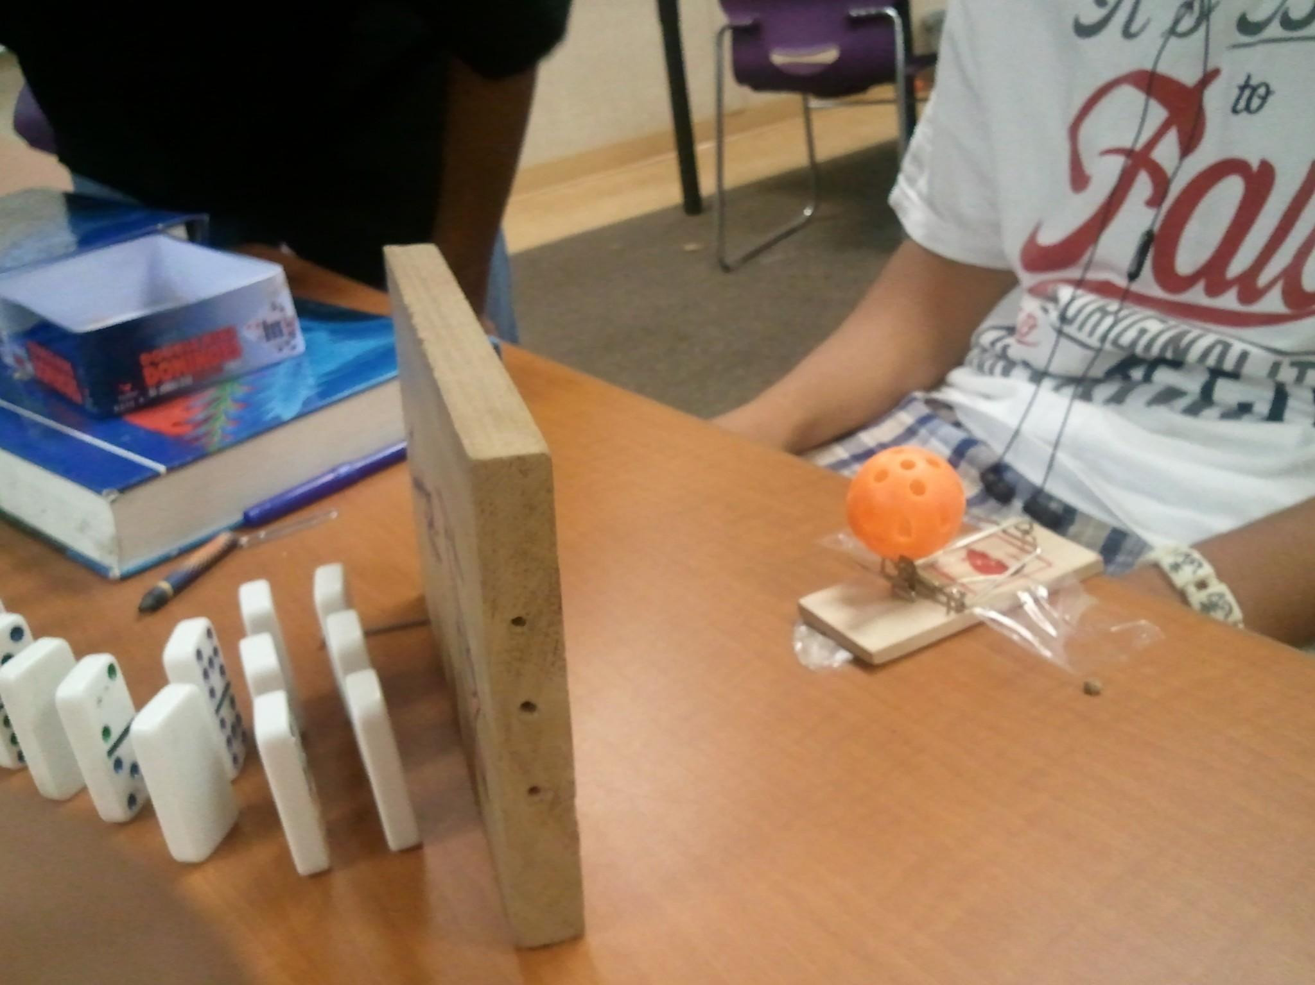 The plank gets knocked over and the top of the plank falls on the ‘catch’ of the mousetrap. After the plank falls on the ‘catch’, it releases the ‘hold down bar’ of the mousetrap. When the hold down bar is released, the ‘hammer’ of the mousetrap along with the projectile (wiffle ball) propel forward. The ‘hammer’ of the mouse trap pivots and stops on the ‘platform’ of the mousetrap. But the ball keeps on moving forward with the same velocity due to the Newton’s First law which states that ‘objects in motion want to stay in motion’. The wiffle ball moves at the same speed as the ‘hammer’ of the mousetrap. Since, the ball is not attached to the hammer, it keeps on moving forward with the same velocity it was before, although the ‘hammer’ pivots and stops.

Ruben Romero

The mousetrap is taped to the table in order to reduce the backfire which is caused by Newton’s Third Law that states, ‘every action has equal and opposite reaction’. After the ‘hammer’ strikes the platform of the mousetrap, the energy gets transferred from the mousetrap to the table and the table provides equal but opposite force to the mousetrap, which makes it to jump. Therefore, taping the mousetrap to the table combines the two bodies and the energy that’s distributed on the table is not enough to move it.

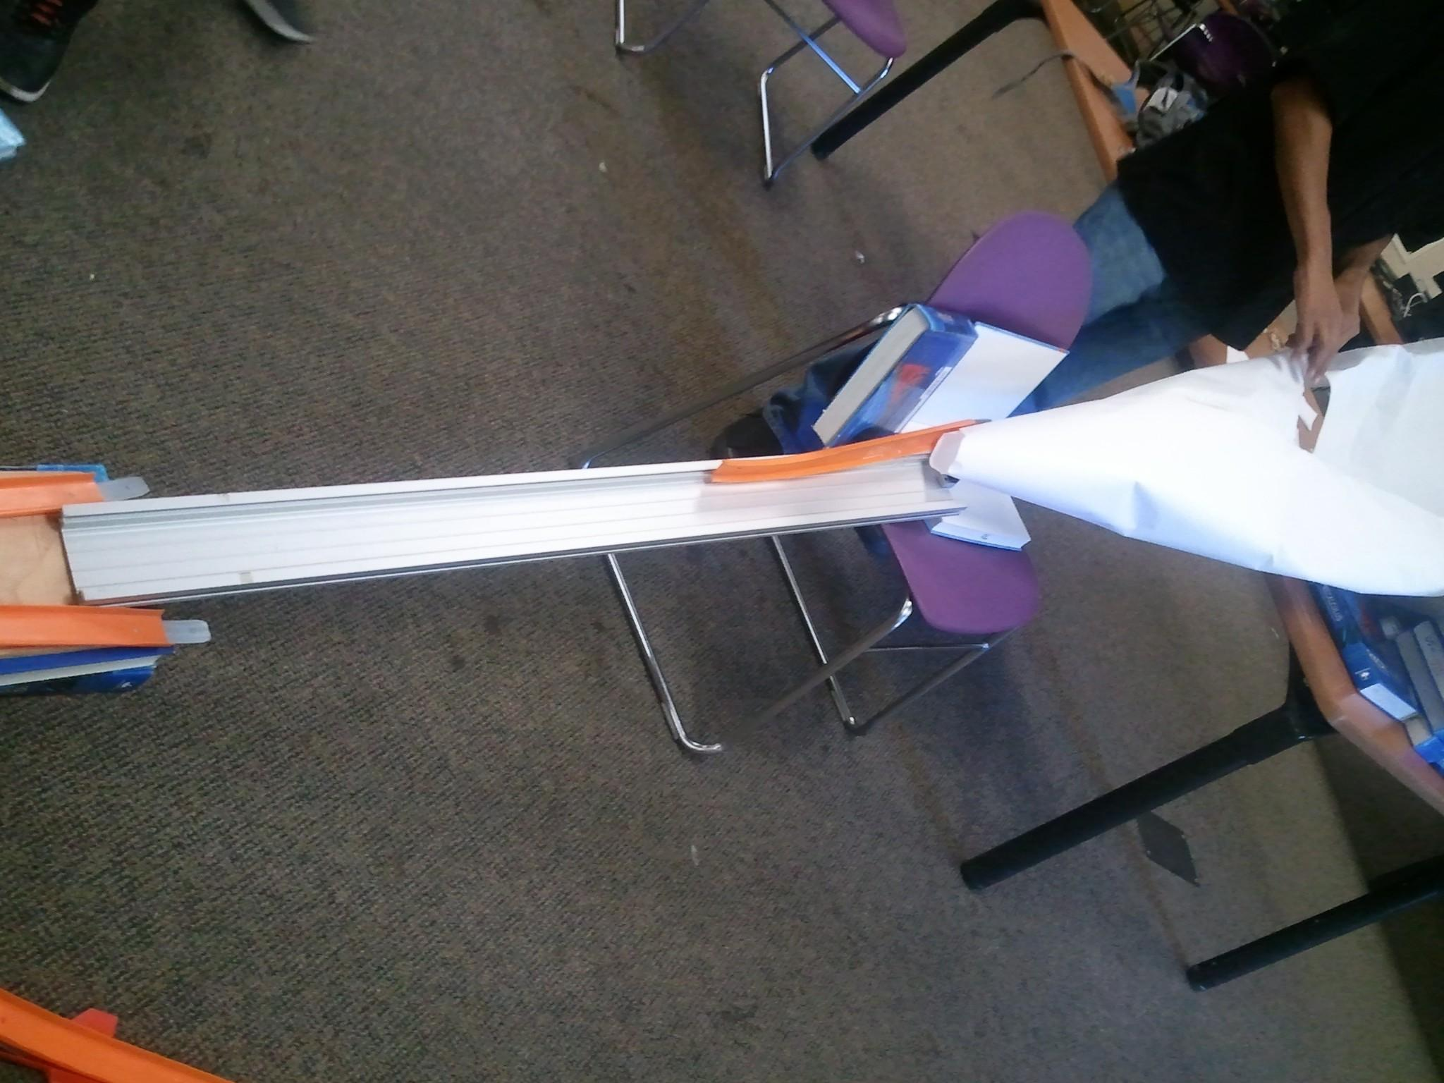

The launched wiffle ball then lands on the ramp, which rolls the ball forward, increasing its velocity, thus also increasing its kinetic energy. The ball then gains kinetic energy that is enough to knock down the domino at the end of the platform.

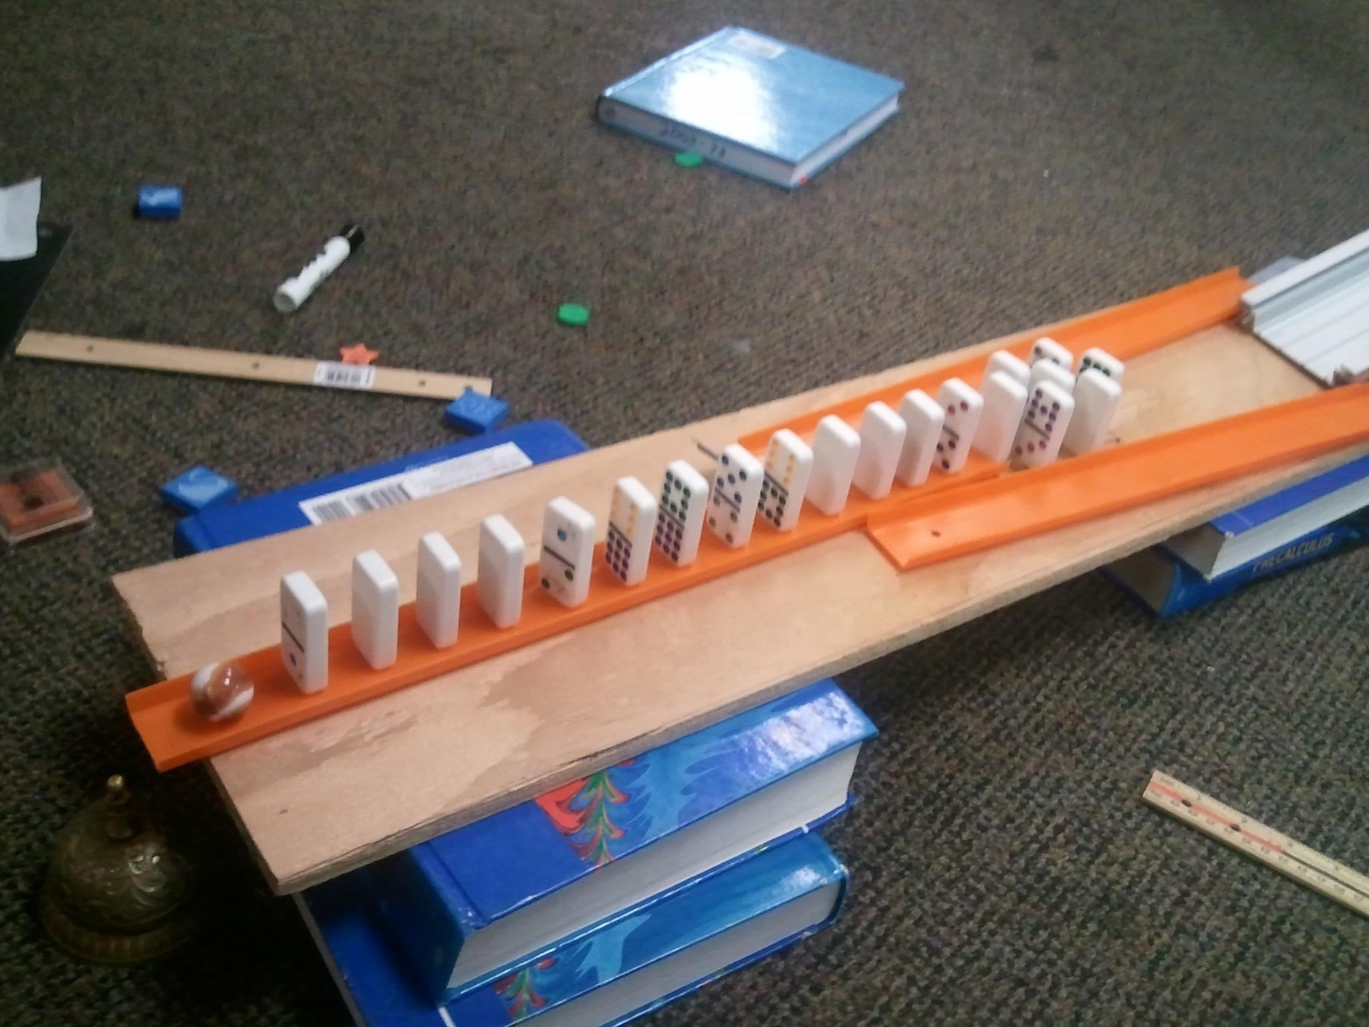

The dominoes knock each other out and then at the end, the last domino falls on a marble that’s at the end of the platform, which gives it kinetic energy. The marble then rolls forward and falls down the platform on top of the bell. The fall gives the marble, additional kinetic energy, which is enough to ring the bell.

