Brick by Brick
Development Group

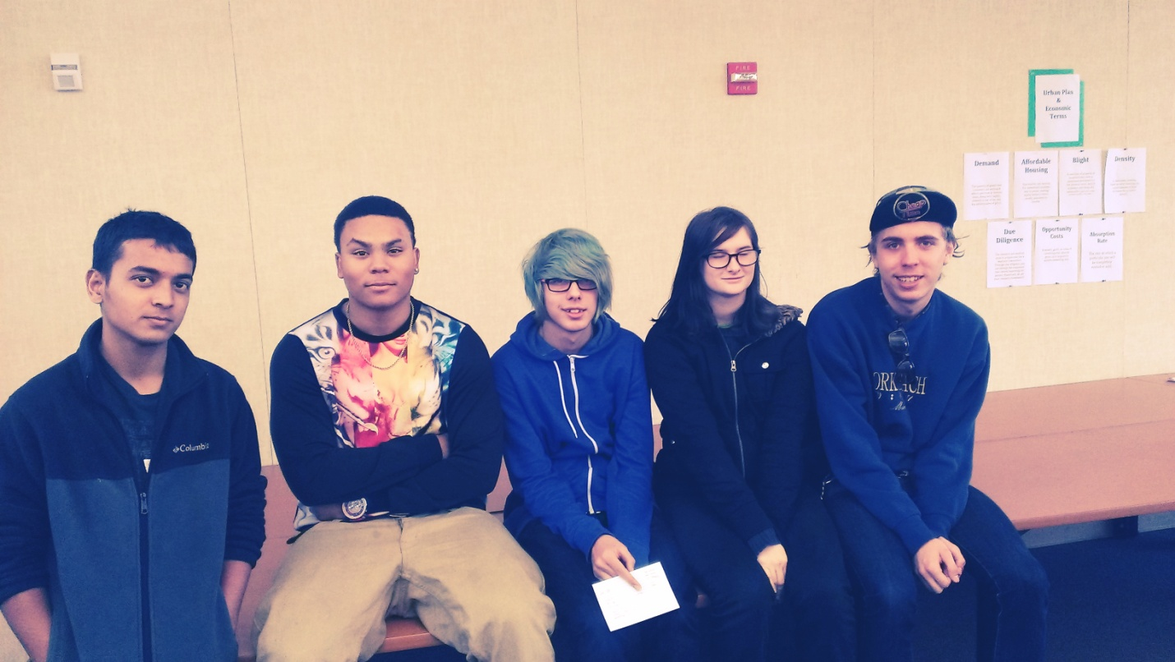

Team Page

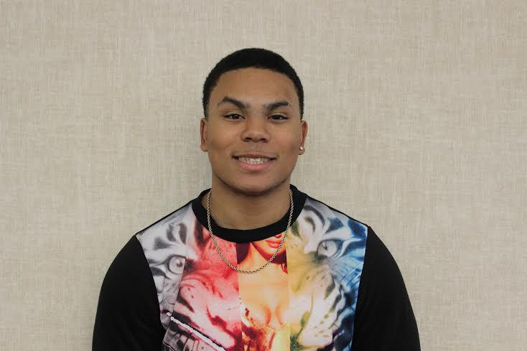

Andre Togia - Marketing Director

Anish Mishra- Site Planner

Mark Hutchason- Financial Analyst

Miles Wilson- Neighborhood Liaison

Kathryn Urbik- City Liaison

Table of Contents

- Vision Statement…………………………………………………………….5
- Colored 2-D Site Map………………………………………………………..6
- Digital Photos of the Plan…………………………………………………….7
- Marketing Director……………………………………………………………8
- City Liaison…………………………………………………………………...10
- Neighborhood Liaison………………………………………………………..11
- Site Planner…………………………………………………………………..12
- Financial Analyst……………………………………………………………..14
- Use Allocation………………………………………………………………...15
- Value…………………………………………………………………………..16
- City Revenue………………………………………………………………….17
- Summary……………………………………………………………………….18

Vision Statement
Our vision as the Brick by Brick Development Group is to transform the neighborhood of Elmwood into a vivid new place for people from all socioeconomic backgrounds. Our target is to enhance the economy by redeveloping Elmwood to attract businesses and residents to shape the community. We want the small and local businesses to flourish through neighborhood retails. Our plan includes a supermarket that will fulfill the needs of the local residents while also providing them with entry and professional level job opportunities. The uses of low-rise and mid-rise office buildings will attract small businesses. We will support the low-income families through affordable housing and entry level employment opportunities. Our plan also includes the use of amenities such as parks which will increase the appeal of the neighborhood and provide the people a place to hold community events and recreational activities.

2-D Site Map

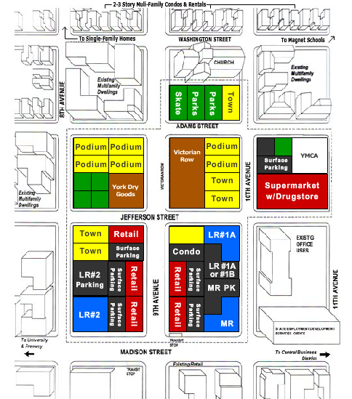

Digital Photos of the Site
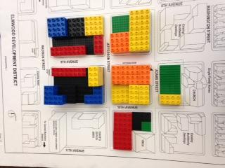
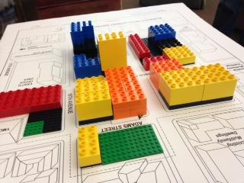
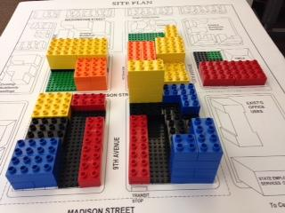

Marketing Director

My name is André Togia and I have chosen the role as marketing director in order to get a better understanding of how the marketing world works. My role as marketing director states that I will be analyzing data from the financial analyst, and I must be able to defend placement of buildings we put in our site plan; I must be able to sale and lease all of the new buildings we have put in our site plan.

· Our plan builds to market demand because before there were not much affordable housing and office space and now even though the demand is basically never ending we have put in a sufficient amount of affordable housing and office space.

· Under market demand the uses we decided to build were podium apartments because there is a demand for podium apartments and since we can get 75 units filled in one year we agreed that this will be good for living, plus podium apartments are mixed around with medium income and low income families.

· We also built townhouses because even though the demand is low it was a good idea since some people like to live in nicer living spaces and we can fill. Plus townhouses are affordable and qualified users exceed 100 units a year. Town houses are also market which brings 17 units a year.

· We built the supermarket because the neighborhood wanted a grocery/drug store close to where they live.

· Finally we built a luxury condo in order to meet and exceed the minimum return rate of 13.5.

· There are a couple buildings that use market demand and those are townhouses and podium apartments.

· The placements of the buildings are harmonious and the housing is placed not too close and not too far from where the citizens of the city work just like they wanted it to be.

· We have the luxury condominium right next to a lot of retail, a park, and the supermarket so that way everything is very easy to access. The placement of our buildings flow so perfectly from the way my group and I see it.

· In our plan we have amenities such as basketball, Skate Park, big recreational park and a relaxing park next to the library along with smaller amenities around the community.

City Liaison

As the City Liaison, the job was to make sure the City’s needs and goals were met within the limits given by the city of Elmwood. In this project the City was Elmwood, the city’s surroundings had to be taken into consideration as well.

· Elmwood is in need of offices, retail and residential buildings, and in a way that would make the overall neighborhood more vibrant while also being profitable for the city in its financial return, and absorption rate.
· Blighted influences such as the Homeless shelter and the make-shift skate park were removed; both of these items were more liabilities than actual functioning facilities.
· Our plan does not meet the wants of the Grace Memorial Church’s request because we got rid of the homeless shelter.
· The highest priority – City’s needs within what can be done and in a way that can fit with its surroundings.

Neighborhood Liaison
My role as neighborhood liaison is to make sure that the neighborhood’s wants and needs were met to the best of our project’s ability.
- Old Urbanists
  - Given lots of retail as requested
  - Given walkable areas as requested
  - Denied the want for Q mart
- Skate On!
  - Given new skate park
- Neighborhood Alliance
  - Given no Q mart
  - Given no homeless shelter
  - Denied request for no low income housing
- Jobs and Justice
  - Given low income housing
  - Given entry level positions in area
  - Denied homeless shelter
- ProArt
  - Denied free space for artists

Site Planner
As a site planner, my job is to come up with a physical plan that reflects the group’s vision statement. We wanted the neighborhood of Elmwood to be culturally and economically diverse by including a variety of retail, office spaces and residential options. I drew inspirations for our site plan from the streets in Downtown, Sacramento.
- We decided to keep Victorian row because it can be used to fulfill the non-neighborhood requests like the University extension and the bike sharing.
- We decided to remove the homeless shelter because the shelter is a blight influence and can reduce the appeal of the neighborhood. Therefore, we decided that it would be ideal to move the homeless shelter somewhere else.
- We decided to renovate the York Dry Goods building and convert it into a police substation and also a library.
- Our vision is to enhance the neighborhood of Elmwood through employment opportunities and businesses, which can be achieved through our financial plan.
- Multiple options for retails, such as the supermarket with grocery and the neighborhood retails in the neighborhood will fulfill the demands of the residents and also provide them with employment opportunities.
- The use of mid-rise offices will attract medium scale businesses and middle-high income families in the neighborhood.
- The use of open spaces will increase the appeal of the neighborhood by providing places to hold events and other outdoor activities.
- The affordable housing and luxury residence will attract people from all sorts of socioeconomic background.
- The use of buildings fit together within the community. The places with high flow of traffic have been separated from the houses which have families with children.

Financial Analyst
In our plan our city plan, from a financial standpoint, fits all of the needs of the RFP and more. As the financial analyst I had to take the role of a mediator between the groups and have them use their resources to create profitable venues for the city in place of unneeded buildings.

- By giving the team a selection of buildings that can be used to generate profit for the city, I had created criteria that the site planner had to adhere to.
- The site plan created a total of 1,380 and offers both low-skill/entry level jobs and high-skill jobs.
- The mid-rise offers the highest developer profit in our city plan. Returning about 6.8 million dollars back.
- Our developer profit is about 13.3 million dollars.
- Our city’s ten year net revenue is about 2 million dollars, 500,000 over what the city wanted.
- The absorption rate of the city cannot surpass 3 years. All of our buildings fall under 3 years to fully absorb:
  - Office - 2.72 years
  - Retail - 2.92 years
  - Residential - 1.71 years

Use Allocation
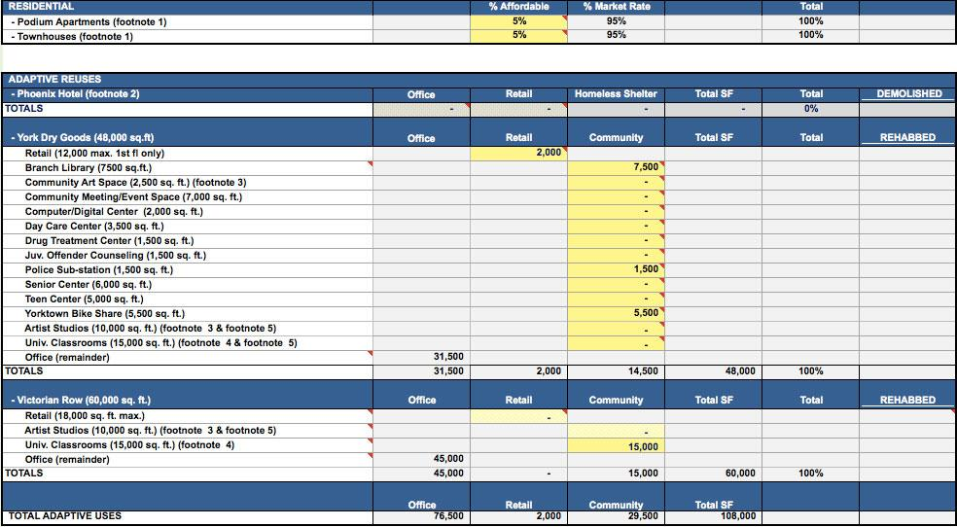

Value
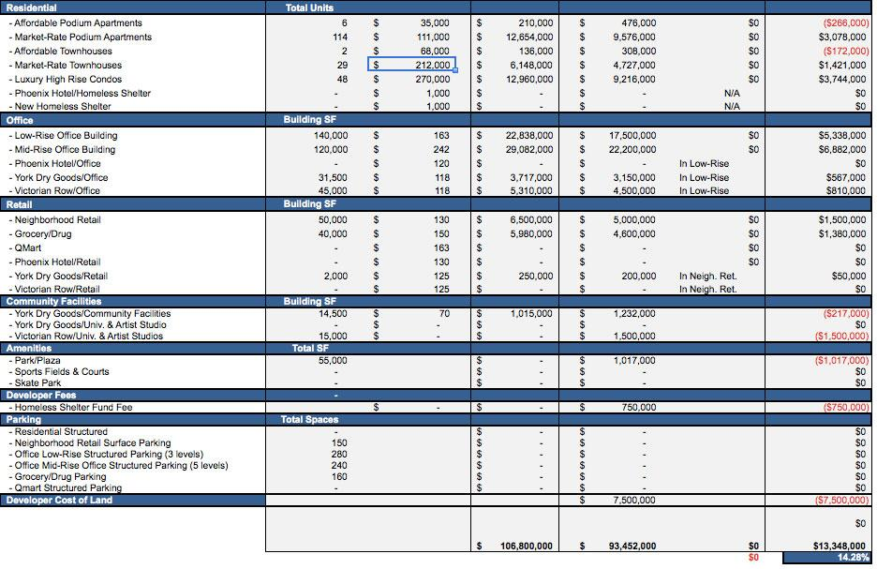

City Revenue

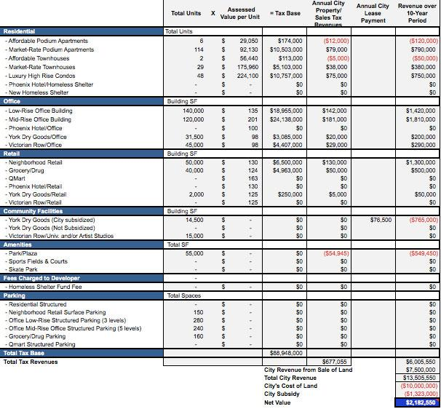

Summary
